**NAME:** Savan Yeshwanth Rao

**CSUID:** 2784780

**LAB-4 IP REPORT**

1. The IP address of my computer is: - **172.20.5.19**

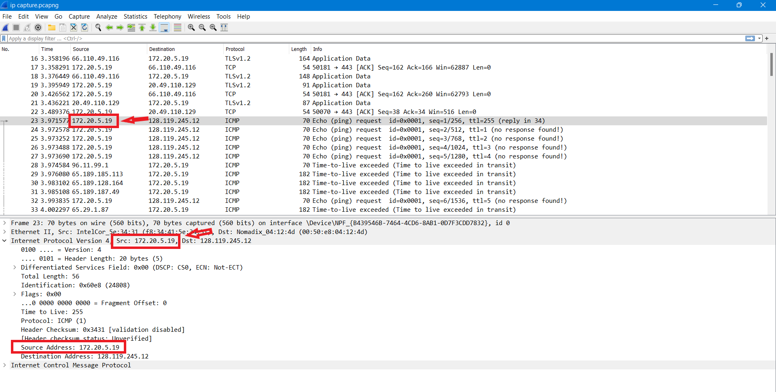

1. In the header, the value of the upper layer protocol field is ICMP (0x01)

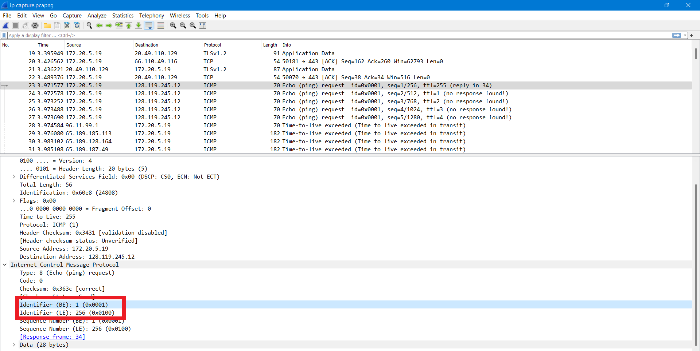

* There are **20 bytes** of IP header.
* There are **36 bytes** in the payload of the IP datagram.
* To determine the number of payload bytes we need to subtract the total length and the header length i.e., There are 20 bytes in the IP header, and 56 bytes total length, this gives 36 bytes in the payload of the IP datagram.

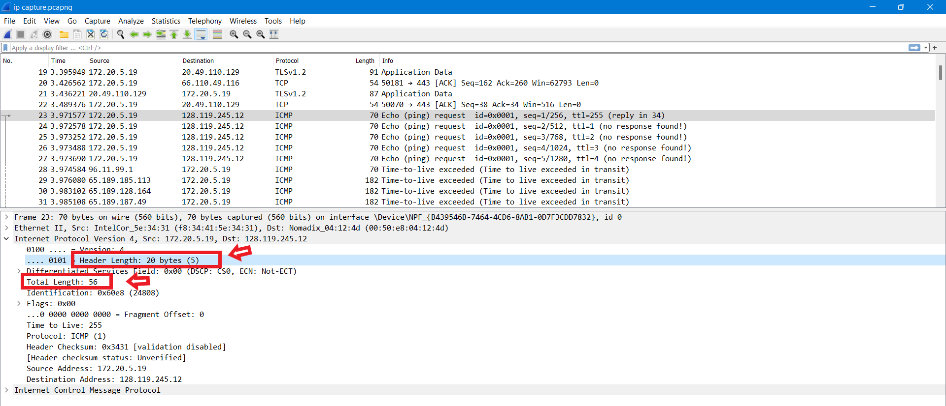

1. No, its not fragmented as we can see form the picture below the more fragments bit = 0, so the data is not fragmented. It is determined by seeing in the flag bit of IP Header field.

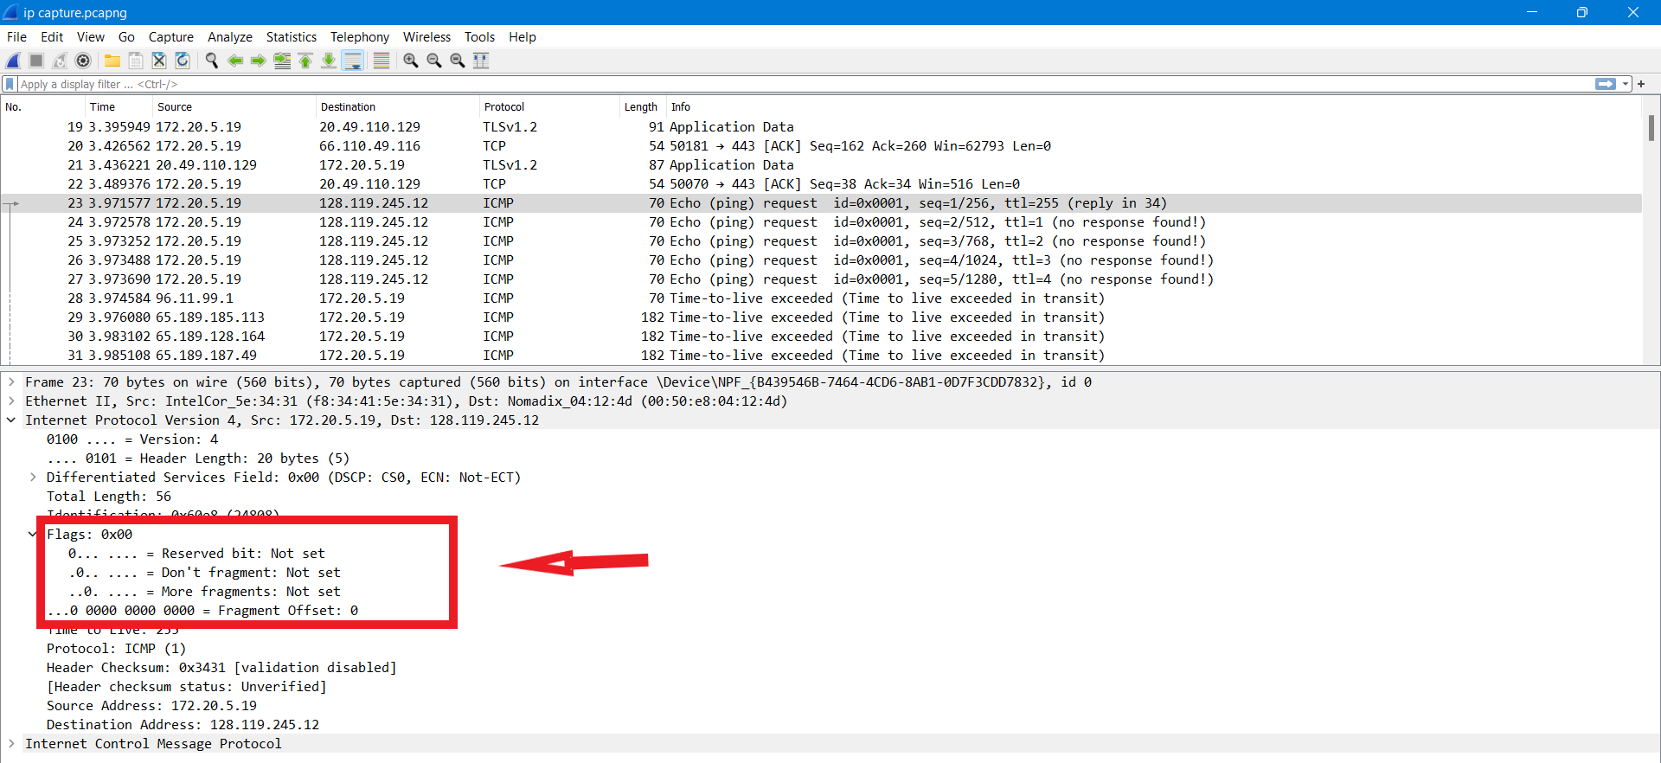

1. The fields that always change are

* **Identification,**
* **Time to live and**
* **Header checksum**.

We can see the changes below in given pictures:

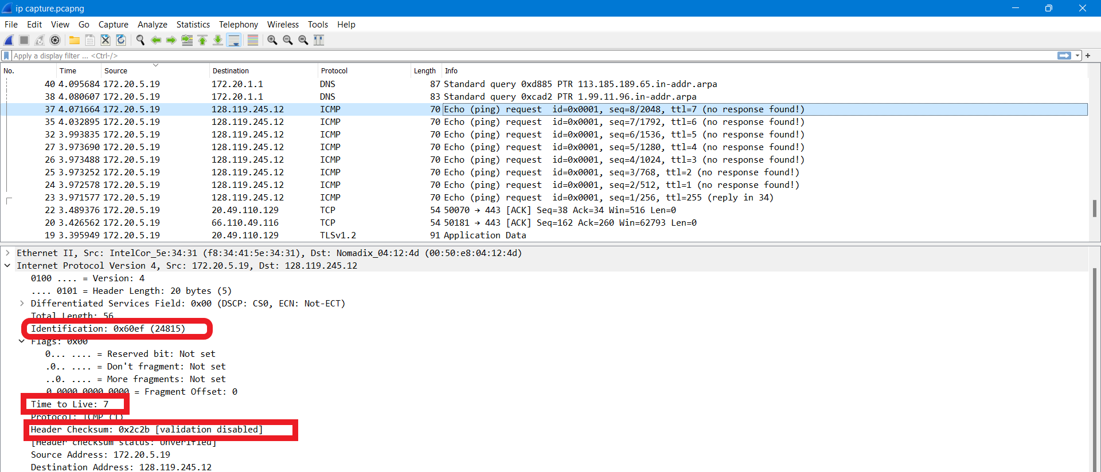

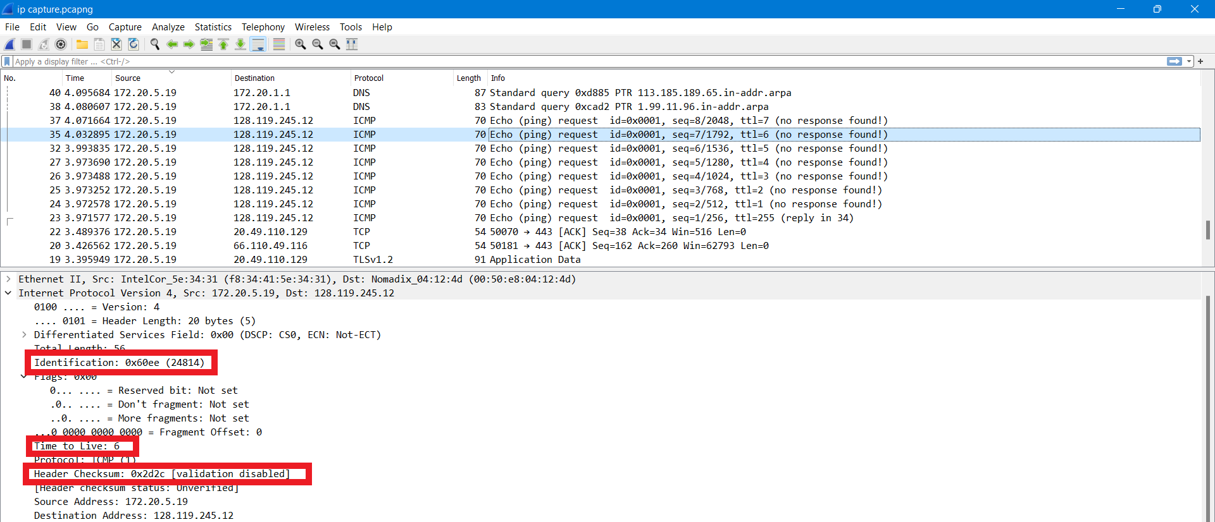

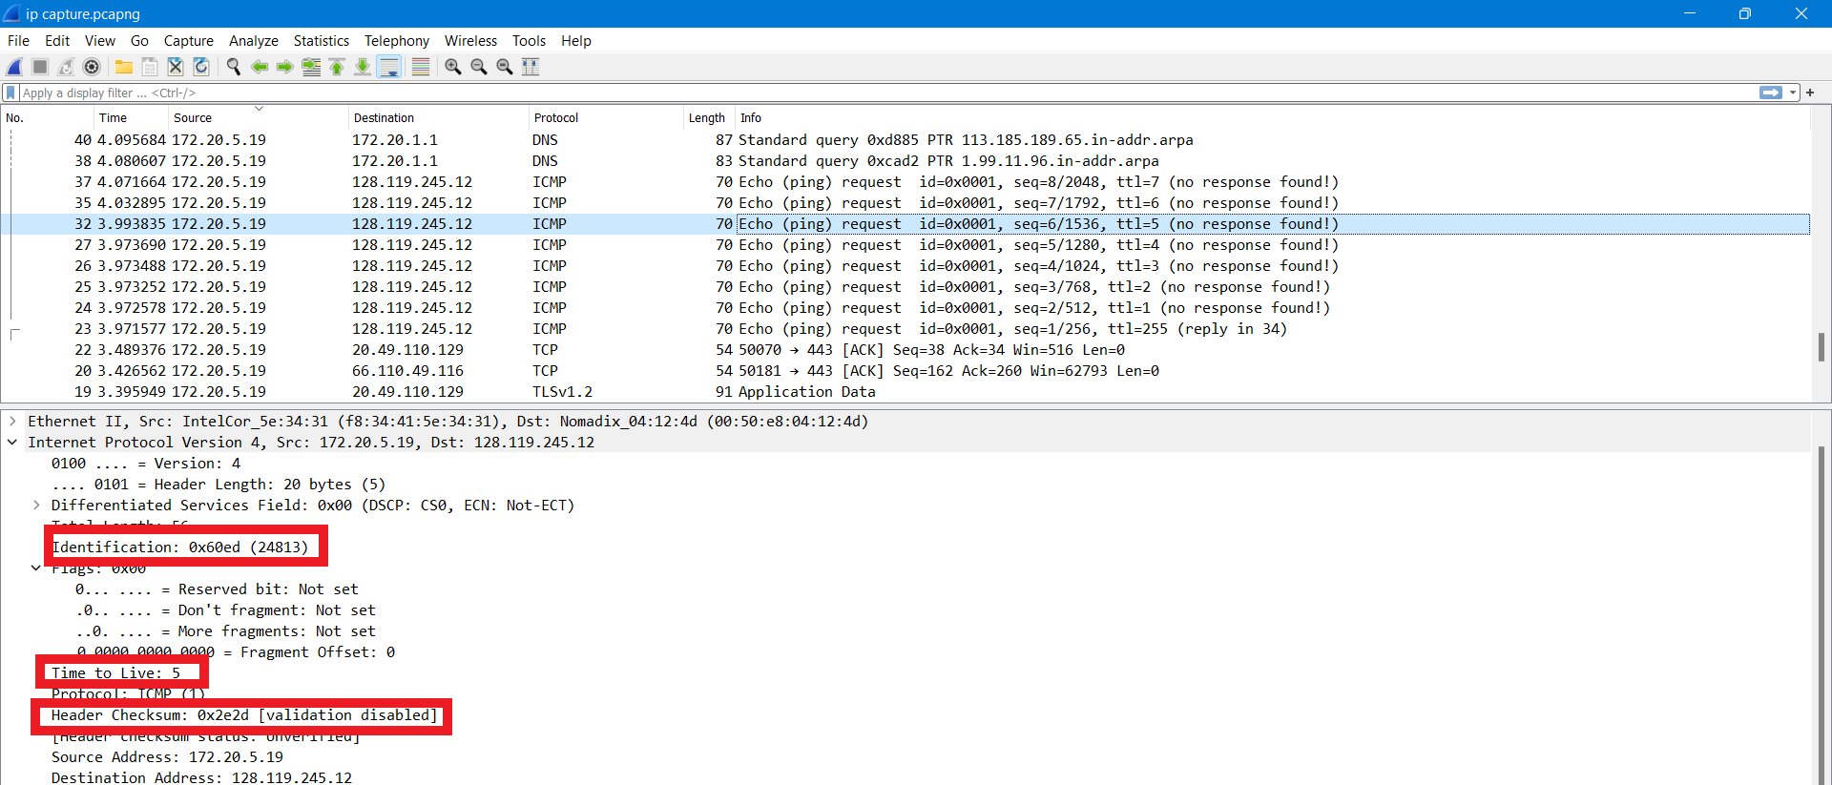

* The fields that must stay constant across the IP datagrams are:
* **Version**, because we are using IPv4 for all packets captured.
* **Header length**, because these are ICMP packets.
* **Source IP**, as we are sending from the same source.
* **Destination IP**, since we are sending to the same destination.
* **Differentiated Services**, because all packets are ICMP they use the same Type of Service class.
* **Upper Layer Protocol**, since all are ICMP packets.
* The fields that must stay constant are same as the above solution i.e.,
* **Version**, because we are using IPv4 for all packets captured.
* **Header length**, because these are ICMP packets.
* **Source IP**, as we are sending from the same source.
* **Destination IP**, since we are sending to the same destination.
* **Differentiated Services**, because all packets are ICMP they use the same Type of Service class.
* **Upper Layer Protocol**, since all are ICMP packets.

Some of the cases are shown below in the pictures:

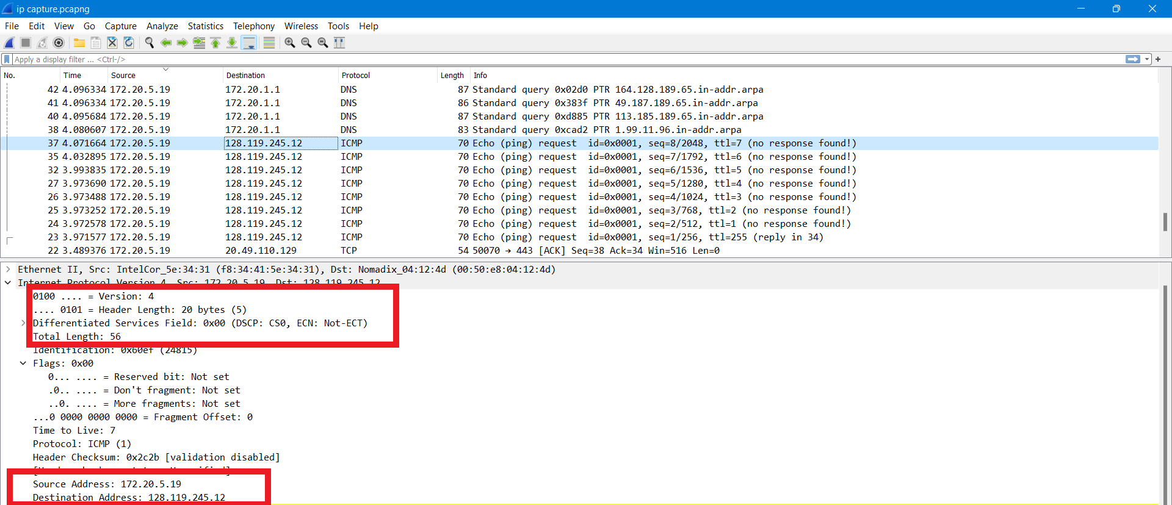

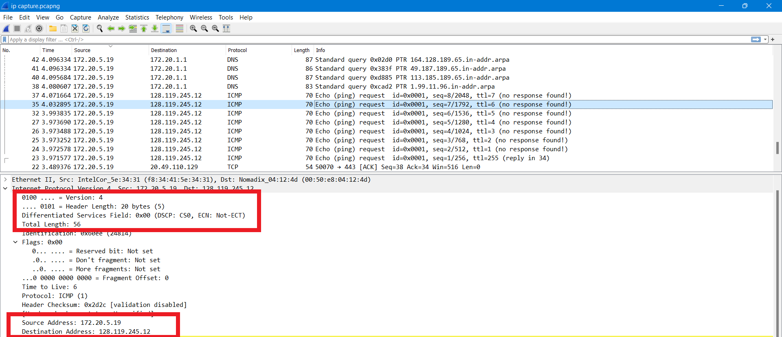

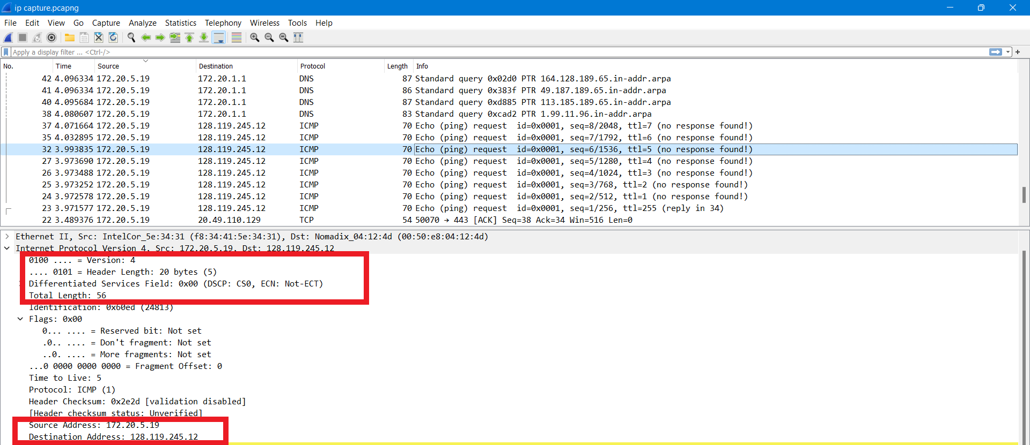

* The fields that must change are similar to solution number 5 and the pictures are also provided in question number 5:

• **Identification**, because IP packets must have different ids.

• **Time to live**, because traceroute increments each subsequent pack.

• **Header checksum**, because since header changes, so must checksum.

1. As we can see from the screen, the pattern is that the IP header Identification fields increment with each ICMP Echo (ping) request.

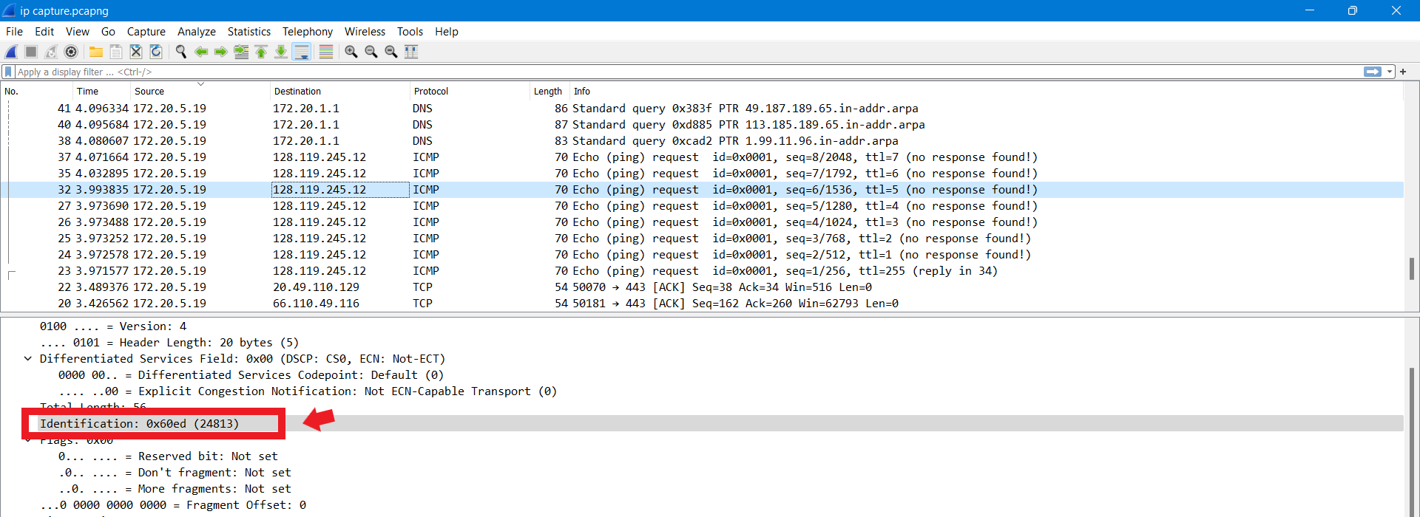

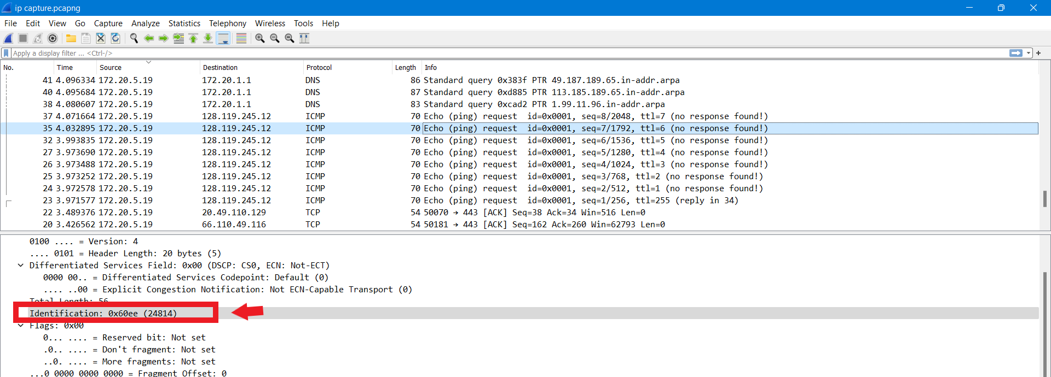

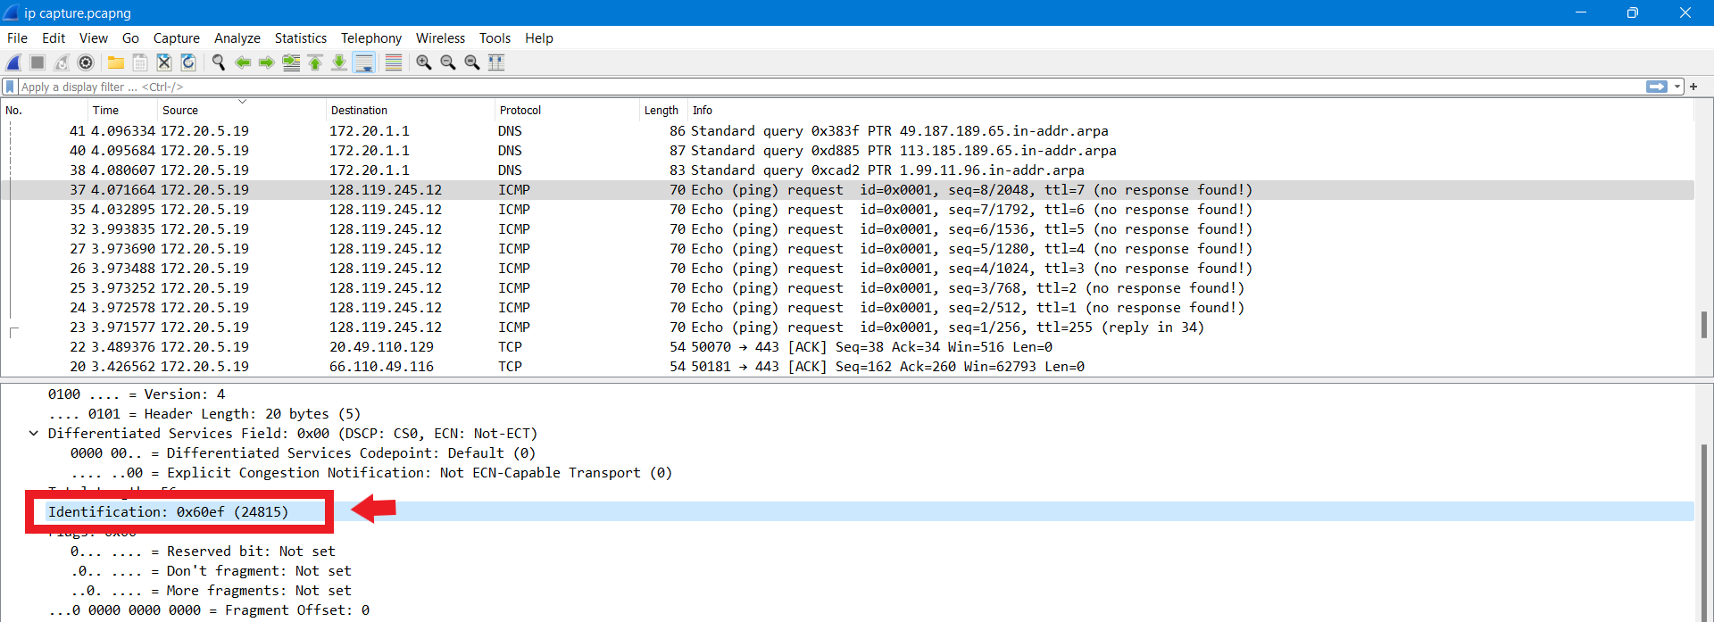

1. According to the 1st hop router from my computer:

**Identification:** **0** and **TTL: 255.**

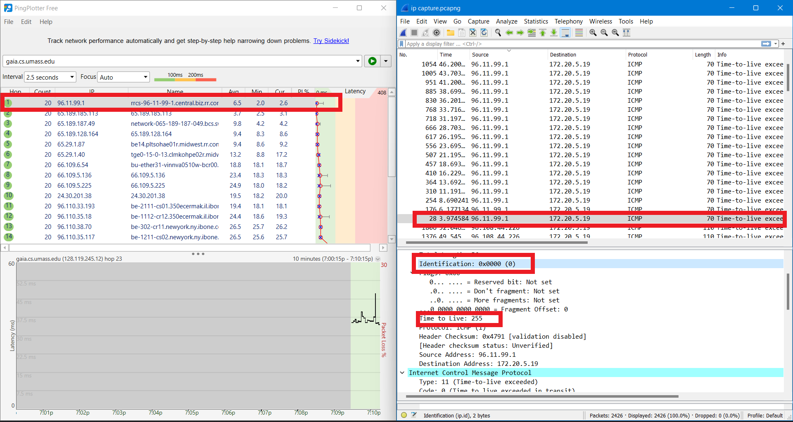

1. The identification field always changes for all the ICMP TTL-exceeded replies which is because the identification field is a unique value for each time.

The Time-to-live field remains unchanged for the same router because the Time-to-live for the first hop router is always the same.